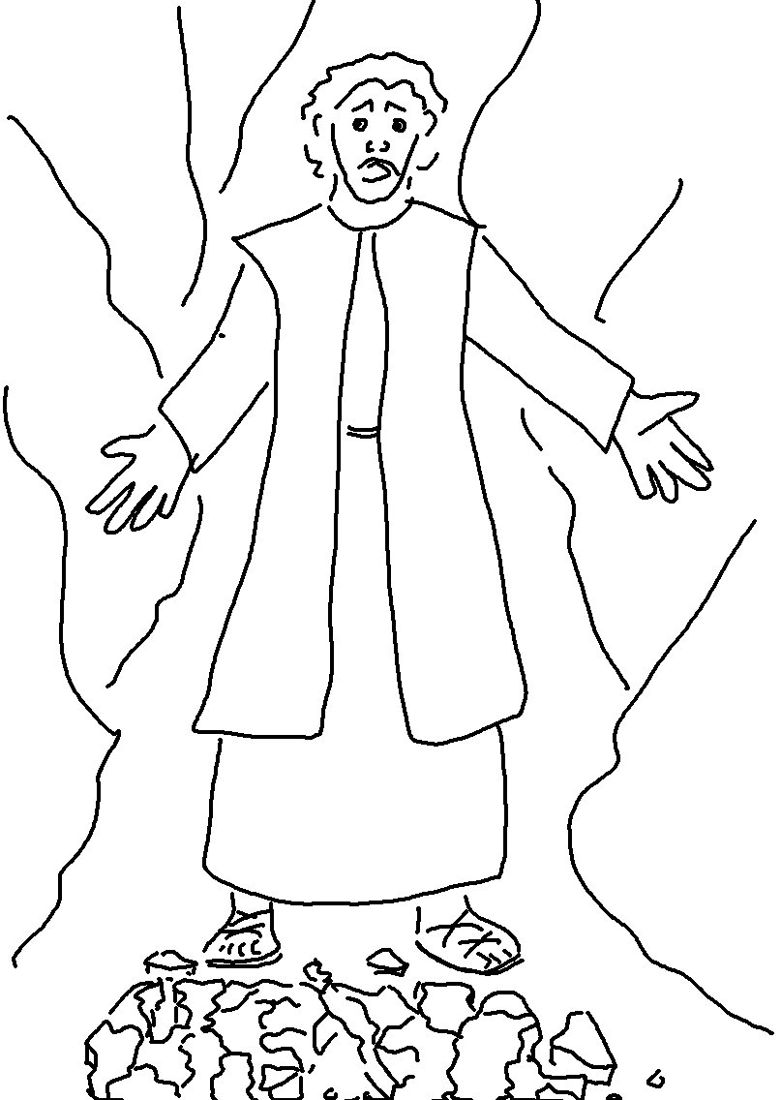
"You must not have any other _ _ _ but _ _."
Exodus 20:3_{NLT}

